**DS PRACTICAL 06**

**AIM :- Implement a Stack and perform the stack operations: Infix to Postfix, Infix to Prefix, Evaluation of Postfix Expression, Print using Menu Driver Program such as 1. Infix to Postfix, 2. Infix to Prefix, and 3. Evaluation of Postfix Expression and 4. Exit.**

# Program:-

#include <stdio.h>

#include <stdlib.h>

#include <ctype.h>

#include <string.h>

#define MAX 100

struct Stack

{

int top;

char items[MAX];

};

int isEmpty(struct Stack *stack)

{

return stack->top == -1;

}

char peek(struct Stack *stack)

{

return stack->items[stack->top];

}

char pop(struct Stack *stack)

{

if (!isEmpty(stack)) return stack->items[stack->top--];

return '\0';

}

void push(struct Stack *stack, char ch)

{

stack->items[++stack->top] = ch;

}

int precedence(char ch)

{

switch (ch)

{

case '+': case '-': return 1; case '*': case '/': return 2; case '^': return 3;

}

return -1;

}

// Convert infix to postfix void infixToPostfix(char *exp)

{

struct Stack stack; stack.top = -1;

int i, k;

char output[MAX];

for (i = 0, k = 0; exp[i]; i++)

{

if (isalnum(exp[i]))

{

output[k++] = exp[i];

}

else if (exp[i] == '(')

{

push(&stack, exp[i]);

}

else if (exp[i] == ')')

{

while (!isEmpty(&stack) && peek(&stack) != '(') output[k++] = pop(&stack); pop(&stack); // Remove '('

}

else

{

while (!isEmpty(&stack) && precedence(exp[i]) <= precedence(peek(&stack)))

output[k++] = pop(&stack); push(&stack, exp[i]);

}

}

while (!isEmpty(&stack)) output[k++] = pop(&stack);

output[k] = '\0';

printf("Postfix Expression: %s\n", output);

}

void reverse(char *exp)

{

int n = strlen(exp); for (int i = 0; i < n / 2; i++)

{

char temp = exp[i]; exp[i] = exp[n - i - 1]; exp[n - i - 1] = temp;

}

}

// Convert infix to prefix void infixToPrefix(char *exp)

{

reverse(exp);

struct Stack stack; stack.top = -1;

int i, k;

char output[MAX];

for (i = 0, k = 0; exp[i]; i++)

{

if (isalnum(exp[i]))

{

output[k++] = exp[i];

}

else if (exp[i] == ')')

{

push(&stack, exp[i]);

}

else if (exp[i] == '(')

{

while (!isEmpty(&stack) && peek(&stack) != ')') output[k++] = pop(&stack); pop(&stack);

}

else

{

while (!isEmpty(&stack) && precedence(exp[i]) < precedence(peek(&stack)))

output[k++] = pop(&stack); push(&stack, exp[i]);

}

}

while (!isEmpty(&stack)) output[k++] = pop(&stack);

output[k] = '\0'; reverse(output); printf("Prefix Expression: %s\n", output);

}

struct IntStack

{ int top;

int items[MAX];

};

int isIntStackEmpty(struct IntStack *stack)

{

return stack->top == -1;

}

int popInt(struct IntStack *stack)

{

return stack->items[stack->top--];

}

void pushInt(struct IntStack *stack, int value)

{

stack->items[++stack->top] = value;

}

// Evaluate postfix expression int evaluatePostfix(char *exp)

{

struct IntStack stack; stack.top = -1;

int i;

for (i = 0; exp[i]; i++)

{

if (isdigit(exp[i]))

{

pushInt(&stack, exp[i] - '0');

}

else

{

int val1 = popInt(&stack); int val2 = popInt(&stack);

switch (exp[i])

{

case '+':

pushInt(&stack, val2 + val1);

break; case '-':

pushInt(&stack, val2 - val1);

break; case '*':

pushInt(&stack, val2 * val1);

break; case '/':

pushInt(&stack, val2 / val1);

break;

}

}

}

return popInt(&stack);

}

int main()

{

int choice;

char exp[MAX];

do

{

printf("\nMenu:\n"); printf("1. Infix to Postfix\n"); printf("2. Infix to Prefix\n"); printf("3. Evaluate Postfix\n"); printf("4. Exit\n"); printf("Enter your choice: "); scanf("%d", &choice);

getchar();

switch (choice)

{

case 1:

printf("Enter infix expression: "); fgets(exp, MAX, stdin); exp[strcspn(exp, "\n")] = 0; infixToPostfix(exp);

break;

case 2:

printf("Enter infix expression: "); fgets(exp, MAX, stdin); exp[strcspn(exp, "\n")] = 0; infixToPrefix(exp);

break;

case 3:

printf("Enter postfix expression: "); fgets(exp, MAX, stdin); exp[strcspn(exp, "\n")] = 0; printf("Result of Postfix Evaluation: %d\n", evaluatePostfix(exp));

break;

case 4: printf("Exit the Program.\n");

exit(0); break;

default:

printf("Invalid choice!\n");

}

} while (1); return 0;

}

# Output

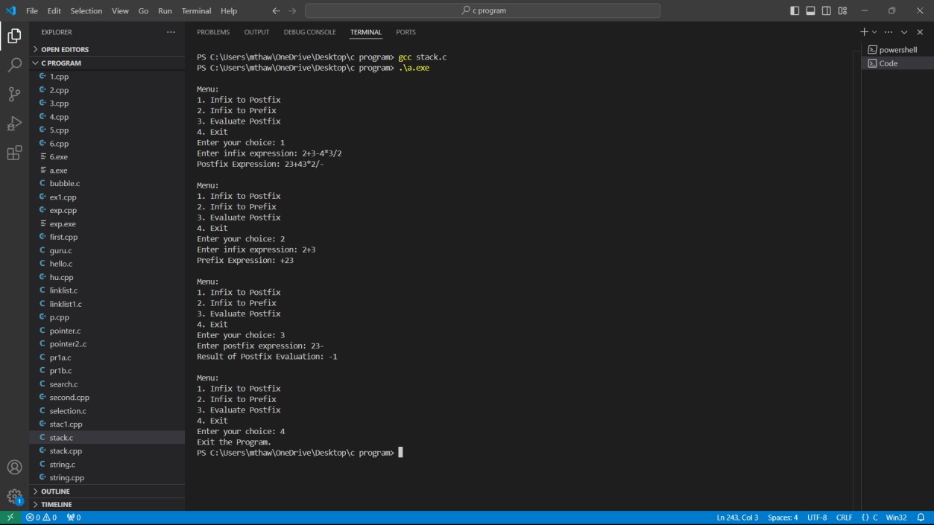

Github link ; <https://github.com/Manas1597/DSA>